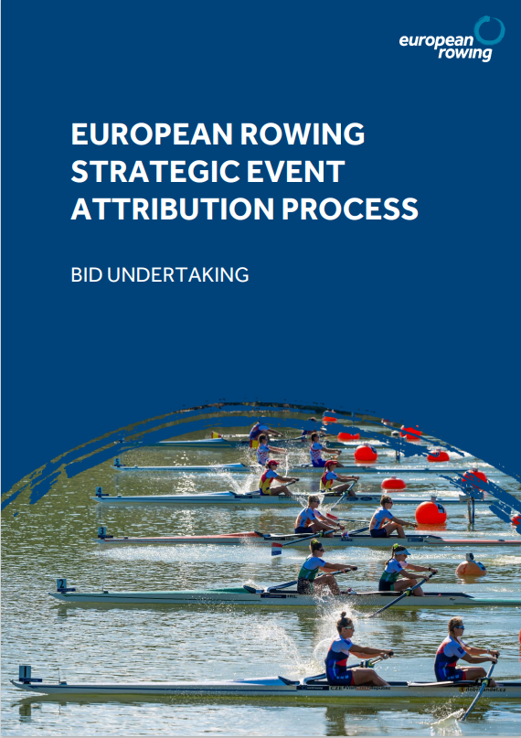

 | 15 December 2023  Lausanne, Switzerland  European Rowing  Maison du Sport International  Avenue de Rhodanie 54  1007 Lausanne  Switzerland  Member Rowing Federation of Country  City of City name  Re: Candidature for the Year & Event name  Confirmation of acceptance of the terms and conditions of the Event and Rights Agreement  Dear Sirs and/or Madams,  With reference to your candidature for the organisation of the Year & Event name (hereinafter "the Event"), you have received the text of an agreement headed "Event and Rights Agreement concerning the staging of the Year & Event name " (hereinafter the "ERA").  The ERA reflects the terms and conditions which will apply to your appointment as organiser in the event that the European Rowing General Assembly or European Rowing Board attributes your Member Federation and City the responsibility of organising the Event.  The acceptance of the terms and conditions of the ERA is part of the candidature process and a condition thereof.  We therefore thank you to confirm that:  1. You have read and understood the terms and conditions of the ERA  2. You accept without any reservation that the terms and conditions of the ERA shall apply in the event that the organisation of the Event is awarded to you and that you are and will remain throughout the period covering the preparation, organisation and staging of the Event in a position to perform any and all obligations deriving from the ERA.  3. In the event that the organisation of the Event is attributed to you, you undertake to sign immediately upon request the ERA without reservation and without requiring any amendments thereto (subject to amendments which World Rowing may at its sole discretion approve).  4. In the unlikely event a dispute arises in connection with the content of this Bid Undertaking, such dispute shall be exclusively settled by arbitration in accordance with the Code of Sports-related Arbitration of the Court of Arbitration for Sport in Lausanne. The place of arbitration will be Lausanne. The language of arbitration will be English.  5. This Bid Undertaking shall remain in full force and effect until either the organisation of the Event has been attributed to you and you will have duly executed the ERA as submitted (subject to any amendments approved by European Rowing and World Rowing at their sole discretion), or the organisation of the Event is awarded to one of the other candidates.  As confirmation of your acceptance of the content of this Bid Undertaking, we thank you to return a copy thereof duly countersigned by authorised representatives listed above with your bid submission.  Yours sincerely,  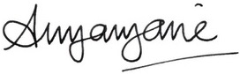  Annamarie Phelps  President  EUROPEAN ROWING  and  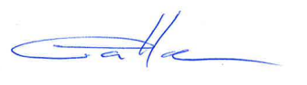  Vincent Gaillard  Executive Director  WORLD ROWING  Read and agreed:  Type Name Here Click or tap here to enter text. Click or tap to enter a date.  Name Title Date  On behalf of the  THE MEMBER ROWING FEDERATION OF Country  Type Name Here Click or tap here to enter text. Click or tap to enter a date.  Name Title Date  On behalf of the  THE CITY OF City name

