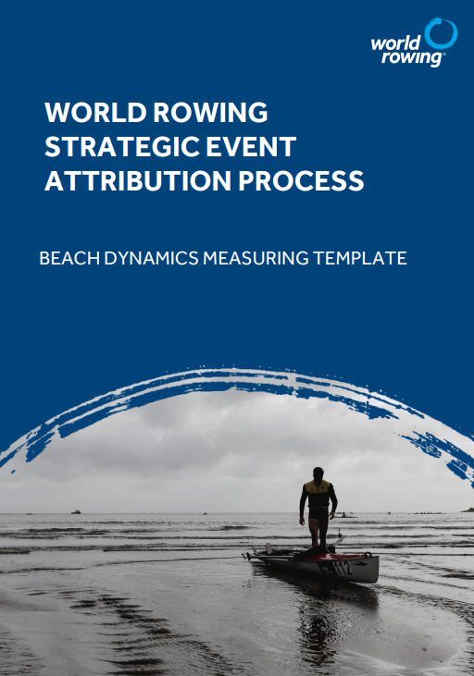
The following data must be measured and submitted to World Rowing with the completed bid dossier. Measurements should be recorded at low tide, high tide, and mid tide, ideally at a comparable tidal dynamic as the days of competition. (i.e., considering neaps, tidal curve etc…)

Equipment needed:
- Tape measure,
- Laser range finder,
- Depth stick,
- Boat,
- Tide data.

- FIELD OF PLAY DESCRIPTION INC. TIDAL INFORMATION

Add all relevant information to describe the field of play, include tidal and wind information etc..

Name of beach | Click or tap here to enter text.
Description of course location | Click or tap here to enter text.
Date | Click or tap here to enter text.
Temperature of water | Click or tap here to enter text.
Sunrise and sunset on race days | Click or tap here to enter text.
Name of the tidal data location | Click or tap here to enter text.
Tidal dynamics & tidal range | Click or tap here to enter text.
Water/beach usage | Click or tap here to enter text.
Notes | Click or tap here to enter text.

- BEACH FLOOR DATA IN BOAT ENTRY ZONE

Provide the depth of the water (meters) at the distances from the water’s edge in the table below.

Instructions: Start in Lane 1. Walk 1m from the water’s edge and record the depth of the water using a depth stick. Walk to 2m from the water’s edge and record the water depth again. Take recordings at 3m, 4m, 5m, 10m, 20m and 30m from the water’s edge.

Complete the process for each lane at low tide, mid tide and high tide.

Low tide depth data
 | Distance from water’s edge (m)
Depth (m) | 1m | 2m | 3m | 4m | 5m | 10m | 20m | 30m
Course A
Lane 1 | m | m | m | m | m | m | m | m
Lane 2 | m | m | m | m | m | m | m | m
Course B
Lane 1 | m | m | m | m | m | m | m | m
Lane 2 | m | m | m | m | m | m | m | m

Type of wave | Click or tap here to enter text.
Type of beach material | Click or tap here to enter text.
Notes | Click or tap here to enter text.

Mid tide depth data
 | Distance from water’s edge (m)
Depth (m) | 1m | 2m | 3m | 4m | 5m | 10m | 20m | 30m
Course A
Lane 1 | m | m | m | m | m | m | m | m
Lane 2 | m | m | m | m | m | m | m | m
Course B
Lane 1 | m | m | m | m | m | m | m | m
Lane 2 | m | m | m | m | m | m | m | m

Type of wave | Click or tap here to enter text.
Type of beach material | Click or tap here to enter text.
Notes | Click or tap here to enter text.

High tide depth data
 | Distance from water’s edge (m)
Depth (m) | 1m | 2m | 3m | 4m | 5m | 10m | 20m | 30m
Course A
Lane 1 | m | m | m | m | m | m | m | m
Lane 2 | m | m | m | m | m | m | m | m
Course B
Lane 1 | m | m | m | m | m | m | m | m
Lane 2 | m | m | m | m | m | m | m | m

Type of wave | Click or tap here to enter text.
Type of beach material | Click or tap here to enter text.
Notes | Click or tap here to enter text.

- DATA ON WATER’S EDGE MOVEMENT DURING RACE DAYS (MEASURE OVER 12 HRS)

Measure the changes in distance of the water’s edge during a similar tide dynamic of a race day (i.e. same tidal curve and range).

Select a permanent reference point at the back of the beach (e.g. tree trunk) and measure the distance (metres) to the water’s edge every 30 minutes from 06:00 until 19:00.
Calculate the difference in distance (metres) once all measurements are taken.

Note: If the water movement is likely to be less than 10m, please only provide the HWT and LWT tides times.

Description back of beach measurement point | Click or tap here to enter text.
Date | Click or tap here to enter text.
Time of HWT/ LWT | Click or tap here to enter text.
Tidal range | Click or tap here to enter text.
Notes | Click or tap here to enter text.

Time | Distance water’s edge to back of beach measurement point (m) | 30min difference (m)
6:00 | m | m
6:30 | m | m
7:00 | m | m
7:30 | m | m
8:00 | m | m
8:30 | m | m
9:00 | m | m
9:30 | m | m
10:00 | m | m
10:30 | m | m
11:00 | m | m
11:30 | m | m
12:00 | m | m
12:30 | m | m
13:00 | m | m
13:30 | m | m
14:00 | m | m
14:30 | m | m
15:00 | m | m
15:30 | m | m
16:00 | m | m
16:30 | m | m
17:00 | m | m
17:30 | m | m
18:30 | m | m
19:00 | m | m

- Course depth

Measure the depth at the buoy positions. Ideally measure at low water or at high water.

Depth (m) | Slalom 1 (85m) | Slalom 2 (170m) | Turn Buoy (250m)
Course A
Lane 1 | m | m | m
Lane 2 | m | m | m
Course B
Lane 1 | m | m | m
Lane 2 | m | m | m

Notes | Click or tap here to enter text.

The data may need to be re measured if storms change the dynamics of the beach.

END
December 2023

