IOC Climate Action Award 2025 Applications
ATHLETES

Judging Criteria
The potential eligible Winner will be chosen entirely on merit, based on the criteria set out below.
The Athlete has developed an innovative project for addressing climate change within their sport and is using their sphere of influence to educate others on climate change with clear objectives and outcomes.

As a minimum the Athlete will demonstrate:
- The positive climate impact of the project (or, if the project has not been fully implemented, has a way to demonstrate impact)
- How they are using their sphere of influence to educate others on climate change and their project, potentially including their:
  - Sport
  - Club or team
  - Country
  - Fanbase and/or followers
- Plans for the future of this project to extend its reach and impact.

Please supply answers to the questions detailed in the table below.
This can be through any format you choose and include attachments and links.
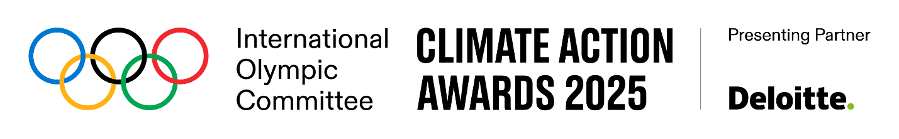
Please complete the following fields with your organisation’s details.

First Name | Nominee’s First Name
Last Name | Nominee’s Last Name
Country Represented | Nominee’s Country
Contact Phone Number | Contact’s Phone Number
Olympic/Paralympic Games Participation | Nominee’s Games Participation
Email Address | Nominee’s Email Address
Phone Number | Nominee’s Phone Number
Relevant Website or Social Media | Nominee’s Website or Social Media Links (optional)
Project overview (maximum 200 words) | Please provide an overview of your project and explain how it is addressing climate change in your sport
Project motivation (maximum 50 words) | Please explain why you are passionate about this project
Project impact (maximum 200 words) | Please explain the positive impact your project is having
Educating others (maximum 150 words) | Please explain how you are using your platform to educate others on climate change and your project
Future vision and impact (maximum 200 words) | Please identify your future vision for this project, including next steps and key lessons learned. Include details on the impact you hope to achieve

(tick box mandatory) I acknowledge that I have read and understood the Application Terms (Deloitte CAA Terms) and agree with their terms and conditions. I confirm that I have been informed that in case I would like to withdraw my consent to the terms and conditions of the Application Terms, I would not be entitled to participate in the IOC Climate Action Awards anymore.
(tick box mandatory) I am not currently serving any sanctions, measures or provisional suspension imposed against me in relation to a) a contravention of the Olympic Charter, the IPC Handbook, or any other applicable regulation issued by the IOC or the IPC, b) any doping-related offence or c) any other act against the integrity of sports competitions (e.g. match fixing).
(tick box mandatory) I hereby confirm the information that I have provided is complete, true and accurate and understand that the IOC, IPC, and/or Deloitte may conduct appropriate verifications, including via interviews, and background checks, as and to the extent provided in the Application Terms, and they reserve the right in their absolute discretion to disqualify my Application should they become aware of any inaccuracy, dissimulation, fraud, deceit, or similar action / omission.
(tick box mandatory) I confirm I have read and understood the IOC privacy policy, including the additional data protection information provided in the Application Terms (Deloitte CAA Terms). I acknowledge that the IOC shares my personal data with Deloitte Global Services Limited based in the USA who will process my personal data in the USA, UK, Canada and Switzerland and that my personal data will be processed pursuant to the Application Terms (Deloitte CAA Terms) and the Deloitte Privacy Notice located here: Privacy (deloitte.com). In case I am a Paralympic athlete, I also acknowledge that the IOC and the IPC, based in Germany, will share my personal data among them and that my personal data will be processed pursuant to the Application Terms (Deloitte CAA Terms) and the IPC Privacy Policy (privacy@paralympic.org).
(tick box optional) Sign me up to receive Olympic updates and partner offers digitally from the International Olympic Committee (IOC). You can unsubscribe at any time via the unsubscribe link available in each email you will receive. See the IOC’s privacy policy for more information.

Signature of Athlete:

About Deloitte
Deloitte refers to one or more of Deloitte Touche Tohmatsu Limited (DTTL), its global network of member firms, and their related entities (collectively, the “Deloitte organization”). DTTL (also referred to as “Deloitte Global”) and each of its member firms and related entities are legally separate and independent entities, which cannot obligate or bind each other in respect of third parties. DTTL and each DTTL member firm and related entity is liable only for its own acts and omissions, and not those of each other. DTTL does not provide services to clients. Please see www.deloitte.com/about to learn more.

Deloitte provides leading professional services to nearly 90% of the Fortune Global 500® and thousands of private companies. Our people deliver measurable and lasting results that help reinforce public trust in capital markets and enable clients to transform and thrive. Building on its 180-year history, Deloitte spans more than 150 countries and territories. Learn how Deloitte’s approximately 460,000 people worldwide make an impact that matters at www.deloitte.com.

